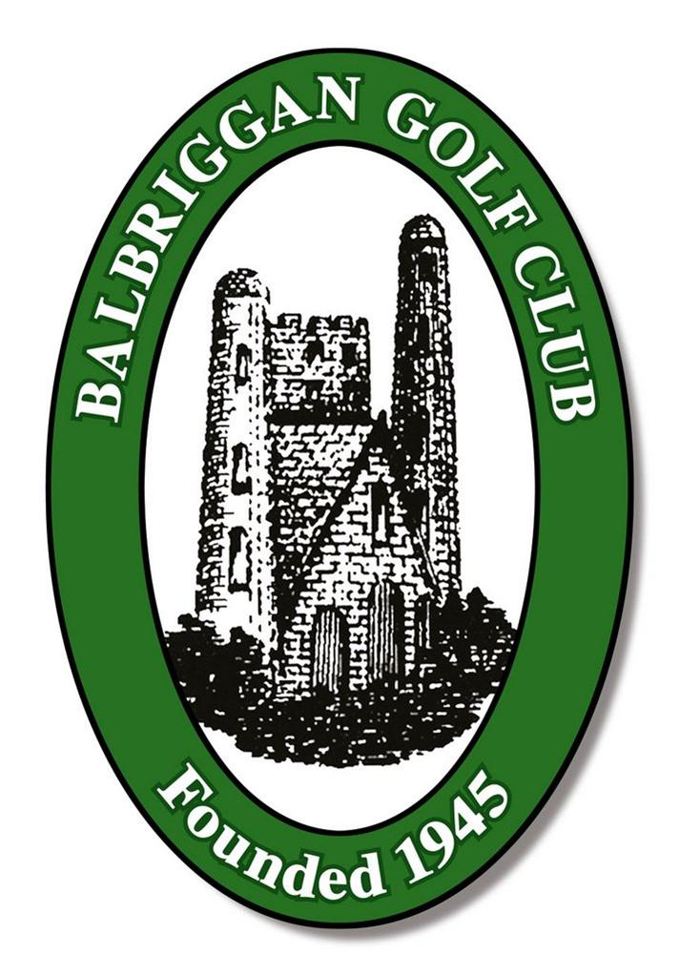
Balbriggan Golf Club

Social Inclusion Policy
20 August 2025

Policy Statement
Balbriggan Golf Club is committed to fostering an inclusive, welcoming, and respectful environment for all individuals. We believe that golf should be accessible to everyone, regardless of age, gender, race, ethnicity, disability, sexual orientation, socioeconomic background, or any other characteristic.

Purpose
This policy outlines our commitment to social inclusion and sets out the principles and practices that guide our efforts to ensure that all members, guests, staff, and visitors feel valued and included.

Scope
This policy applies to:
- All staff and volunteers
- Members and guests
- Contractors and suppliers
- Visitors to the golf course

Principles of Inclusion
We are committed to:
- Respect and Dignity: Treating everyone with respect and ensuring their dignity is upheld.
- Equal Access: Providing equal access to facilities, services, and opportunities.
- Diversity Celebration: Recognizing and celebrating the diverse backgrounds and experiences of our community.
- Zero Tolerance for Discrimination: Taking a firm stance against any form of discrimination, harassment, or exclusion.

Implementation Strategies
Balbriggan Golf Club will:
- Provide training and awareness programs for staff and volunteers.
- Ensure facilities are accessible to individuals with disabilities.
- Offer inclusive programs and events that cater to diverse groups.
- Review membership and pricing structures to promote affordability and access.
- Establish clear procedures for reporting and addressing discrimination or exclusion.

Roles and Responsibilities

Management: Responsible for policy enforcement and resource allocation.
Staff and Volunteers: Expected to uphold the principles of inclusion in daily interactions.
Members and Guests: Encouraged to contribute to a respectful and inclusive environment.

Monitoring and Review
This policy will be reviewed annually to ensure its effectiveness and relevance. Feedback from stakeholders will be considered in the review process.

Contact and Support
For questions, concerns, or to report an issue related to social inclusion, please contact:
Inclusion Officer / Manager
Name: Séamus Daltún
Email: seamus.daltun@gmail.com
Phone: 087 2466513

Current Inclusion Practices
Balbriggan Golf Club is proud of the steps already taken to promote social inclusion across our community. These include:
Accessible Facilities: Wheelchair accessible paths and ramps, accessible restrooms
Inclusive Membership Options: Discounted rates for junior, Intermediate and senior members
Community Engagement: Youth golf programs, Get Into Golf for women, charity tournaments
Diversity in Staffing: Inclusive hiring practices
Safe and Respectful Environment: Code of conduct, procedures for addressing concerns and/or complaints

Community Use and Membership
Balbriggan Golf Club is actively used by a variety of community groups and individuals.
Community Groups:
Remember Us, disability support group, Fingal Seniors golf society
Junior and juvenile golf clinics held throughout the year with an emphasis on school holidays.
Frequency of Use:
Cadets (6-12) and Juveniles (12-18) have designated coaching and reserved playing slots on the course.
Open Membership Policy:
Membership is open to all applicants throughout the year. Special offers are advertised from time to time to encourage new members. New members aged between 25 and 35 have a reduced fee on a sliding scale.
Outreach and Promotion:
We liaise with the Golf Ireland DEI manager to encourage participation by members of minorities, including LGBTQI+.

